Ideation Phase
Empathize & Discover
Date | 31 January 2025
Team ID
Project Name
Maximum Marks | 4 Marks

Empathy Map Canvas:
An Empathy Map is a simple visual tool used to understand the needs, behaviours, feelings, and challenges of users who use the AI WeatherWise application.
It helps the development team understand how users interact with weather information and what they expect from a smart weather application.
Creating an effective AI WeatherWise solution requires understanding the real problems faced by users, such as checking weather conditions, managing multiple locations, and deciding what activities or clothing are suitable. The empathy map helps the team look at these challenges from the user’s perspective and design useful AI-powered weather insights and recommendations.
Example:
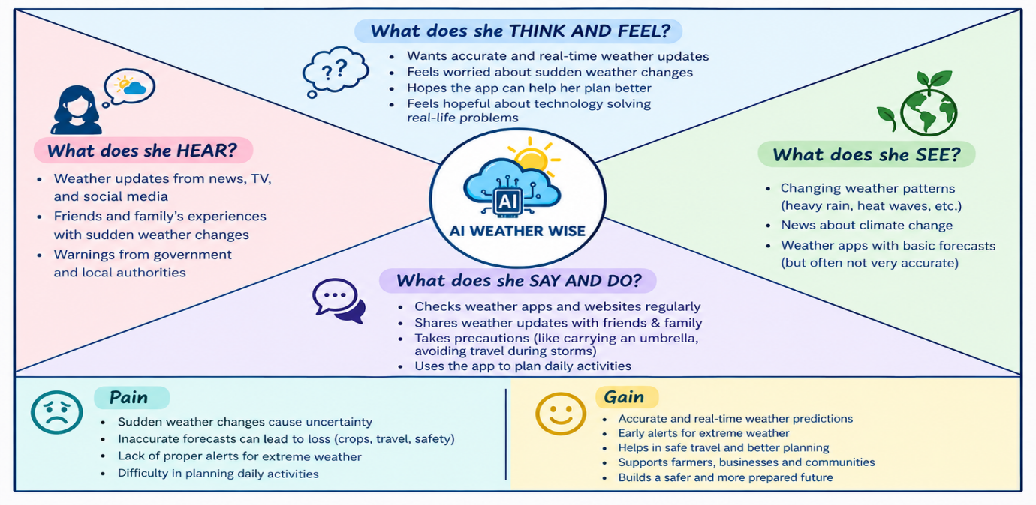

Example: AI Weather Wise – Smart Weather Forecasting and Early Warning System